Stock Analysis using VBA

**Overview of Project: Purpose of Analysis**

The goal of this project is to refactor the existing Stock market Data to ensure it is more efficient and consumes less memory. This will entail improving the logic and providing more documentation as needed

**Background**

Steve loves the workbook you prepared for him. At the click of a button, he can analyze an entire dataset. Now, to do a little more research for his parents, he wants to expand the dataset to include the entire stock market over the last few years. Although your code works well for a dozen stocks, it might not work as well for thousands of stocks. And if it does, it may take a long time to execute.

In this challenge, you’ll edit, or **refactor**, the Module 2 solution code to loop through all the data one time in order to collect the same information that you did in this module. Then, you’ll determine whether refactoring your code successfully made the VBA script run faster. Finally, you’ll present a written analysis that explains your findings.

Refactoring is a key part of the coding process. When refactoring code, you aren’t adding new functionality; you just want to make the code more efficient—by taking fewer steps, using less memory, or improving the logic of the code to make it easier for future users to read. Refactoring is common on the job because first attempts at code won’t always be the best way to accomplish a task. Sometimes, refactoring someone else’s code will be your entry point to working with the existing code at a job.

**Results**

Code refactoring and measure the performance

**Step1:**

Create a tickerIndex variable and set it equal to zero before iterating over all the rows. You will use this tickerIndex to access the correct index across the four different arrays you’ll be using: the tickers array and the three output arrays you’ll create in Step 1b.



Arrays are created for tickerVolume, tickerStartingPrices and tickerEndingPrices



**Step 2:**

A for loop created to initialize the tickerVolumes to zero. If the next row’s ticker doesn’t match, increase the tickerIndex.

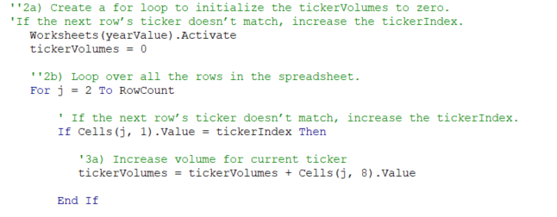

Full Code Snippet

There are comments below that explains every line of the code

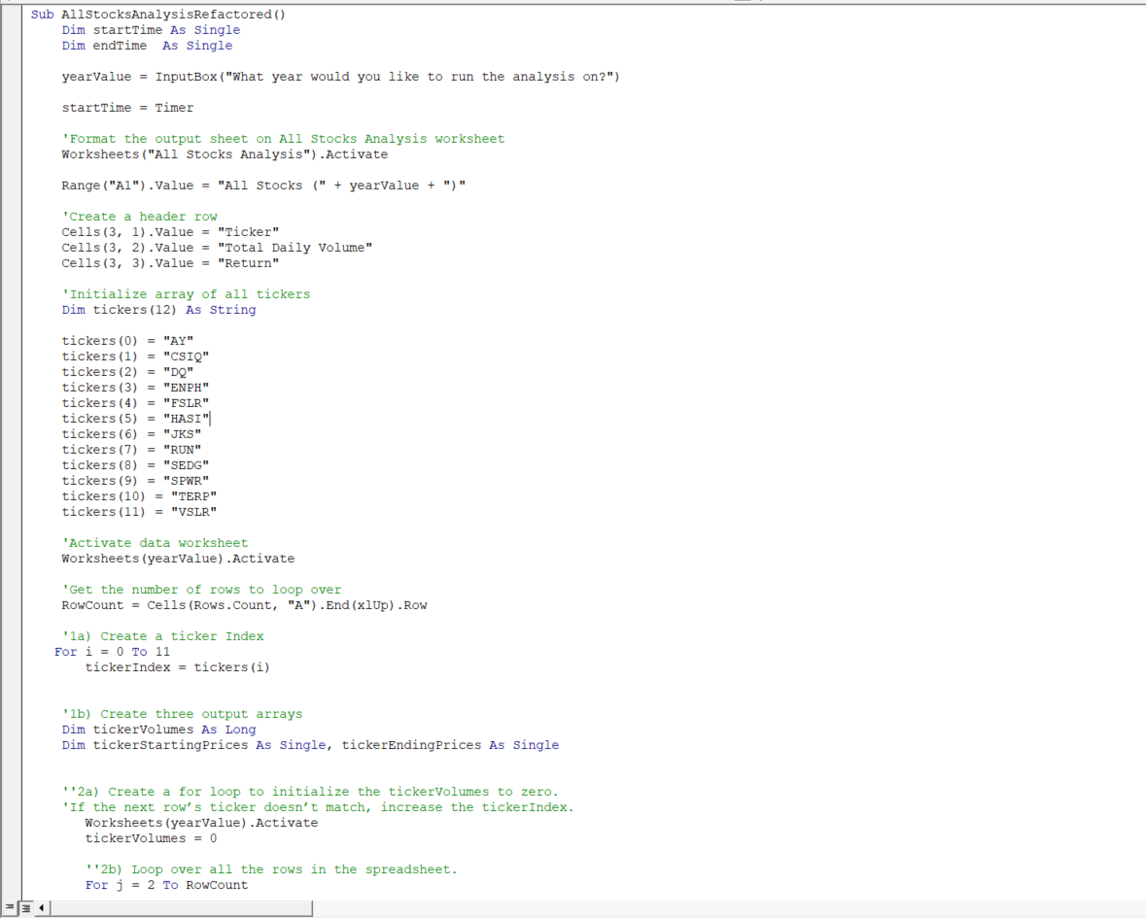

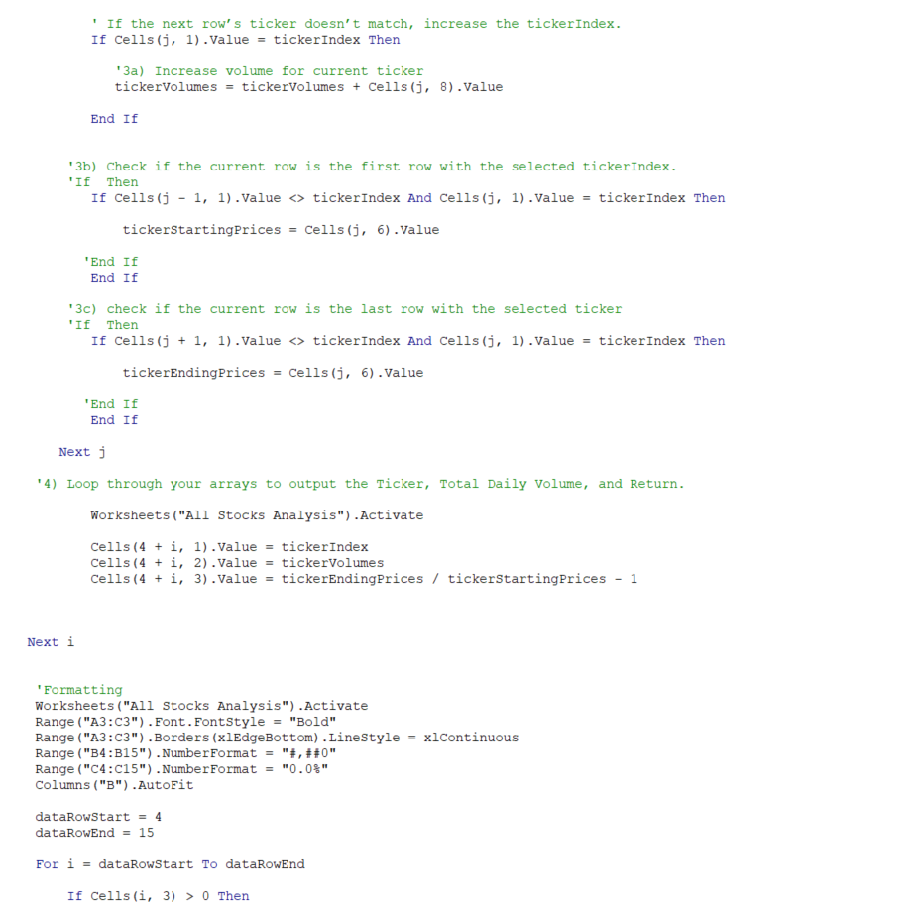

**Analysis comparison between 2017 and 2018**

The analysis is the same as the dataset provided, image shown below. The image is also captured as saved in the resource folder

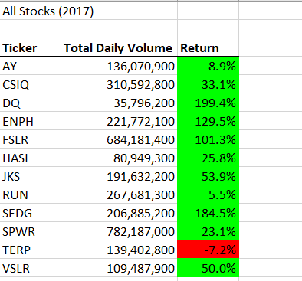

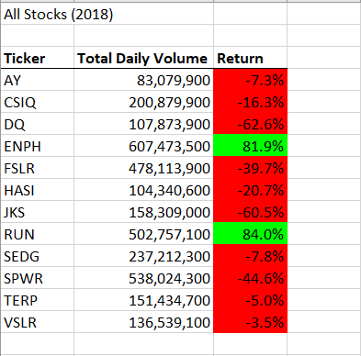

**Time of Run**

**2017**

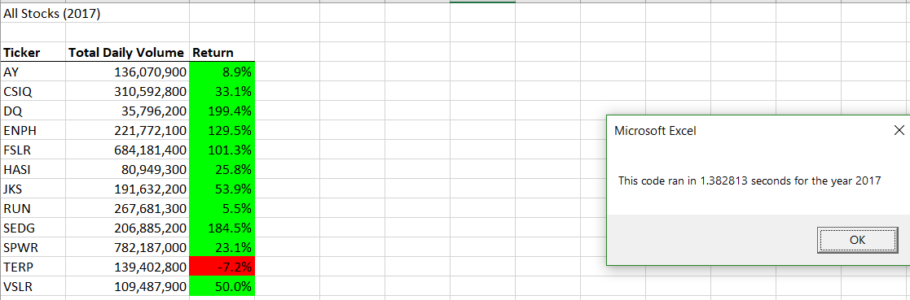

**2018**

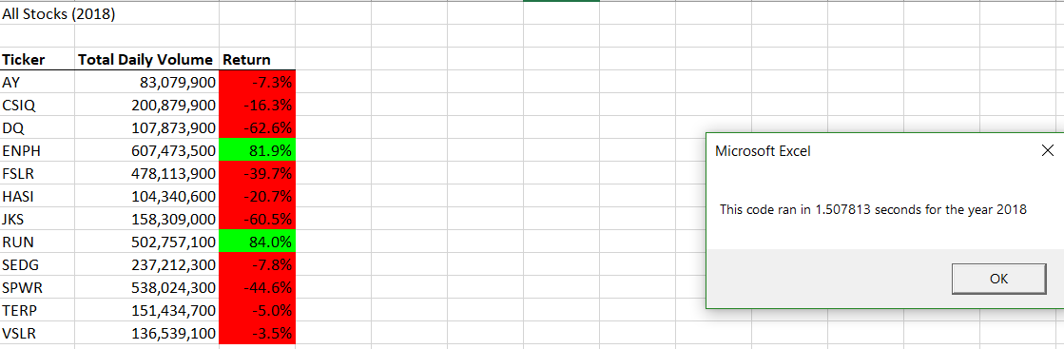

**Summary**

What are the Advantages and disadvantages of refactoring code?

Advantages

* Well structured and documented code are easy to read and debug
* Provides flexibility and easily adaptable when there is need to extend capabilities
* Makes program faster

Disadvantages

* Can be risky if existing code does not have proper test cases set out
* Lack of understanding of the existing code by developers can also be a risk into trying to refactor it

How do these pros and cons apply to refactoring the original VBA script?

* Code refactoring helps to make program run faster and easier to understand. The advantage of code refactors out weighs not refactoring it.